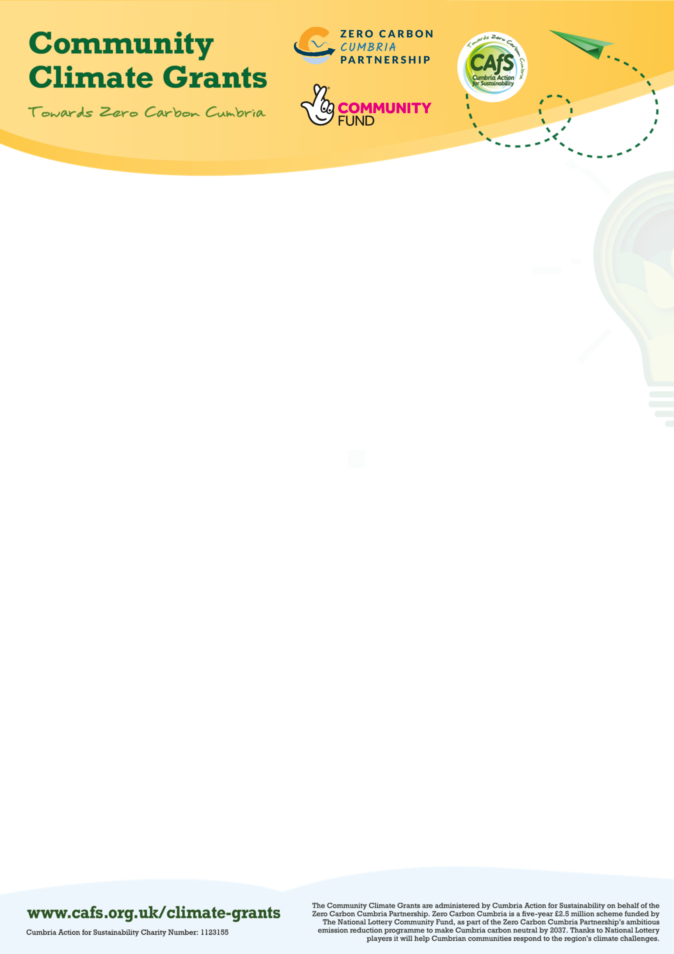

Application Form for grants of up to £750
The main aim of the Community Climate Grants is to support climate action by community groups in Cumbria and to help new sustainability groups get established and existing groups develop further. It is funded by the National Lottery as part of the Zero Carbon Cumbria project and is managed by Cumbia Action for Sustainability (CAfS).
This application has been designed to give us all the information we need to assess your application, meet the National Lottery’s requirements for the distribution of the funding and make the grant payment should your application be approved.

Before completing the application please read the guidance notes and FAQs on the website, in particular please note that:

If you are thinking of applying, please get in touch with communitygrants@cafs.org.uk and we will be happy
to help you.
You can apply if:
- You are a community organisation with a constitution or set of rules1;
- You have a clear environmental or sustainability objective; and
- Your organisation/group is based in Cumbria and is locally controlled.
Further details about the type of organisations which can apply are provided on the guidance notes.

The types of projects we can fund are as follows:

Delivery projects which cover at least one of the following:
- Reducing carbon emissions including those relating to energy use, food, buying things and/or travel.
- Engaging more people and/or building knowledge and understanding of climate change within your community.
- Linking with other projects or activities which will help achieve our target of a Zero Carbon Cumbria by 2037.
Such projects, which have to take place in Cumbria, include events or activities which involve the local community in taking climate action. Further examples are given in the guidance notes.

Development projects which help new and existing sustainability groups:
- Develop skills and knowledge such as media and communications skills
- Build capacity, for example by recruiting more volunteers/members so that the group can take on more activities
Further examples are given in the guidance notes.

Please make sure you download this form and save the application to your computer so that you do not lose any progress. To submit, email to communitygrants@cafs.org.uk with attachments.
If you have any questions please email communitygrants@cafs.org.uk

1 NB: Grants cannot be made to groups which aren’t constituted or to individuals

Section 1. Your Project

What is the name of your project/activity?
Which area of Cumbria will your it be based in?
(Delivery projects only)
When is your proposed start date?
How long do you expect your project to last?

What would you like to do and why? (200 words max)
e.g. what need/issue will it address?
Where appropriate:
How many people (beneficiaries) will take part in your project?
How many volunteers will take part in your project?
What will be the outcomes / benefits? (200 words max)
E.g. how will it help reduce carbon emissions, how will the group benefit, what will be the legacy etc

Please provide details of the costs of your project in the table below:
Please also include quotes for any items of equipment or other capital expenditure.

Description | Costs
TOTAL | £
How much are you requesting from the ZCC Grassroots Community Fund?

Section 2. Your organisation
Please tell us about your organisation - this helps us understand the type of organisation you are.

What is the formal name of your organisation?
What is the main or registered address of your organisation?
When was your organisation set up?
If you have a website, what is the address?
What are your main aims and activities (or proposed activities for a new group)
How many volunteers do you currently have?

What type of organisation are you? If you’re not sure, please check the guidance or contact us

Constituted group or club – i.e. an organisation with a governing document such as a constitution or a set of rules and a committee but not a registered charity or a company.
Registered charity
Charitable incorporated organisation (CIO)
A company limited by guarantee
Community interest company (CIC)
Other – please state:

If you are a registered company, please tell us your company number
If you are a registered charity, please tell us your charity number

Contact details
Please provide details of the person we should contact if we need to discuss your project.

Full name of main contact
Date of birth
Home address
Email
Telephone number
Please tell us about any particular communication needs this contact has.

Finance details
No
Yes
If your application is successful would you like CAfS to make the payment to the supplier directly (if yes, please refer to separate guidance)

If you would like us to pay the grant to you, please provide your bank details below.
Name of your organisation as it appears on the bank statement
Name of your bank
Sort code
Account number
Building Society number
Are 2 or more signatories required for any payment from your bank account |  | Yes No
NB: Please also attach a copy of a bank statement that is less than three months old.

Section 3. Supporting documents
Please check next to each of the following documents to indicate which have been enclosed with this application. NB: Supplying your organisation’s constitution is a requirement of this funding application.

Documents | Enclosed
A copy of your constitution or set of rules
Evidence of your commitment to the environment e.g. organisation’s constitution, vision/mission statement or an environmental policy
Quotes for any items of equipment or other capital expenditure
If you would like us to pay the grant to you:
Bank statement from the last 3 months from all accounts of the organisation/group.
Iyou are planning to work with another group: Partnership agreement

Please check to indicate if the following are available should they be required at a later stage

Documents | Available
The most recent annual accounts of your organisation/group | Yes | No
Insurance certificates | Yes | No
Safeguarding policy & procedures and/or statement | Yes | No
Partnership agreement | Yes | No

Section 5. Terms and conditions
In order to submit your application, you will need to agree to the following terms and conditions:
- By submitting an application to the Zero Carbon Cumbria (ZCC) Grassroots Community Fund, the organisation named in the application (referred to as “you” in these Terms and Conditions) agrees, if awarded a grant, to:
  - hold the grant on trust for ZCC Grassroots Community Fund (referred to as ‘we’ or ‘us’) and use it only for your project as described in your application or otherwise agreed with us, and only for expenditure incurred after the date of your grant award;
  - provide us promptly with any information and reports we require about the project and its impact, both during and after the end of the project;
  - act lawfully in carrying out your project in accordance with best practice and guidance from any relevant regulators, and follow any guidelines issued by us about the project or use of the grant and let us know promptly about any fraud, other impropriety, mismanagement or misuse in relation to the grant;
  - acknowledge National Lottery funding using the common lottery branding in accordance with relevant brand guidelines;
  - hold the grant in a UK based bank or building society account which satisfies our requirements as set out in guidelines and requires at least two unconnected people to approve all transactions and withdrawals;
  - immediately return any part of the grant that is not used for your project or which constitutes unlawful subsidy;
  - where your project involves working with children, young people or vulnerable adults, adopt and implement an appropriate written safeguarding policy, obtain written consent from legal carers or guardians and carry out background checks for all employees, volunteers, trustees or contractors as required by law or our guidelines on The National Lottery Community Fund’s website;
  - Cumbria Action for Sustainability or The National Lottery Community Fund may commission research into and/or evaluation of your funding. You confirm that you will co-operate with any research or evaluation-related activities which we carry out and further confirm that we may use any part of your application and/or project information for research or evaluation purposes;
  - acknowledge that we may carry out post-grant assurance checks to ensure that grants funded under Zero Carbon Cumbria Grassroots Community Fund have been spent in accordance with these terms and conditions and may contact you about this after the grant has been made or spent;
  - comply with data protection laws and obtain the consent of your beneficiaries for you to receive and process their personal information and contact them;
  - keep accurate and comprehensive records about your project both during the project and for seven years afterwards and provide us on request with copies of those records and evidence of expenditure of the grant, such as original receipts and bank statements;
  - allow us and/or the Comptroller and Auditor General reasonable access to your premises and systems to inspect project and grant records; and
  - allow us and The National Lottery Community Fund publicising and sharing information about you and your project including your name and images of project activities. You hereby grant us a royalty free licence to reproduce and publish any project information you give us. You

will let us know when you provide the information if you don’t have permission for us to use it in this way.
- You acknowledge that we are entitled to suspend or terminate the grant and/or require you to repay all or any of the grant in any of the following situations. You must let us know if any of these situations have occurred or are likely to occur.
  - You use the grant in any way other than as approved by us or fail to comply with any of these Terms and Conditions.
  - You fail to make good progress with your project or are unlikely in our view to complete the project or achieve the objectives agreed with us.
  - You have match funding for the project withdrawn or receive or fail to declare any duplicate funding for the same project costs as funded by the grant.
  - You provide us with false or misleading information either on application or after award of the grant, act dishonestly or are under investigation by us, a regulatory body or the police, or if we consider for any other reason that public funds are at risk or you do anything to bring us, The National Lottery Community Fund or the National Lottery into disrepute.
  - You enter into, or in our view are likely to enter into, administration, liquidation, receivership or dissolution.
  - You receive any grant money incorrectly either as a result of an administrative error or otherwise. This includes where you are paid in error before you have complied with your obligations under these terms and conditions and Offer Letter. Any sum, which falls due under this paragraph 2.6, shall fall due immediately. If you fail to repay the due sum immediately, or as otherwise agreed with us, the sum will be recoverable summarily as a civil debt.
- You acknowledge that:
  - the grant is for your use only and we may require you to pay us a share of any proceeds from disposal of assets purchased or enhanced with the grant;
  - we will not increase the grant if you spend more than the agreed budget and we can only guarantee the grant as long as we or The National Lottery continues to operate and we receive sufficient funds from it;
  - the grant is not consideration for any taxable supply for VAT purposes;
  - we have no liability for any costs or consequences incurred by you or third parties that arise directly or indirectly from the project, nor from non-payment or withdrawal of the grant, save to the extent required by law;
  - these Terms and Conditions will continue to apply for one year after the grant is paid or until the project has been completed, whichever is later. Clauses 1.2, 1.4, 1.6, 1.8, 1.10, 1.11, 1.12, 1.13, 3.4, and 3.5 shall survive expiry of these Terms and Conditions; and
  - if the application and grant award are made electronically, the agreement between us shall be deemed to be in writing and your online acceptance of these Terms and Conditions shall be deemed to be a signature of that agreement.

Section 6: Declaration

Please confirm that you agree with each of the statements
You have been authorised by the governing body of your organisation (the board or committee that runs your organisation) to submit this application and to accept the Terms and Conditions set out above on their behalf.
All the information you have provided in your application is accurate and complete; and you will notify us of any changes.
You understand that we will use any personal information you have provided for the purposes described under the Data Protection Statement below.
If information about this application is requested by the National Lottery under the Freedom of Information Act, we will release it in line with the National Lottery’s Freedom of Information policy.
Full name of person completing this form:
Position in organisation:
Signature:
Date:

Data Protection Statement
We know the vast majority of the many thousands who seek and use funding are genuine. However, we have a duty to carry out checks on behalf of the National Lottery on individuals at organisations which apply for grants to ensure that we do not receive fraudulent applications. The personal information we have collected from you may therefore be shared with relevant agencies to verify your identity and with the National Lottery.
Further details of how your information will be used by us, your data protection rights and how to contact us, can be found in our Privacy Policy which is published on our website https://cafs.org.uk/about- cafs/cafs-privacy-policy/
Contact us to request a hard copy by telephoning 01768 210276 or emailing office@cafs.org.uk
The National Lottery’s Data Protection and Privacy Notice can be found on their website https://www.national-lottery.co.uk/privacy-policy

