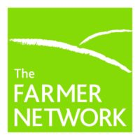
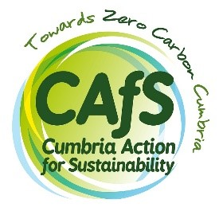

Farm Futures – farmhouse retrofit support.
Expression of Interest
Please complete the following and email to Roe Baker at Cumbria Action for Sustainability:
roe.baker@cafs.org.uk
About you, your farm and your farmhouse:
Name
Address
Email
Phone
Farm(s) name
Farmhouse address
Are you the farmhouse owner, tenant or both?
If you’re a tenant, please confirm whether you have the authority and support of the landowner to engage with us.
[Yes / no]

Farm size – hectares and farm type dairy, beef, sheep, mixed stock, arable or poultry
Which district planning authority are you in?
Have you already calculated your farm carbon emissions and if so which calculator / toolkit did you use?
Is your farmhouse a graded / listed building. Are you in a heritage conservation area?

What is the approximate age of your farmhouse?

Tellus about the construction materials: (sandstone, stone, brick, rendered etc.)

Tell us about the roofing materials:
(Slate, tile, stone flags etc.)
Is the farmhouse detached, semi-detached, terraced, attached to a barn or other farm buildings, other?

Tell us about your current windows: (double glazed, single glazed, sash, timber or PVU, etc)
Tell us about your current insulation (loft, walls, underfloor etc)

Your current services. Are you on mains:
Gas | Y/N
Electricity | Y/N
Water | Y/N
Sewerage | Y/N
If you are on non mains central heating – tell us what kind?
Oil, Calor gas, LPG, electric storage etc.
Do you use a wood burner or multifuel stove?

Tell us about the issues you are facing – is the house damp, draughty, expensive to heat, is there water ingress, what are your key concerns?
[Describe]
Tell us as much as you can about any work you’ve already done to improve the fabric of your farmhouse.
[Describe]
Tell us if you have you already installed any renewables, battery storage (air source or ground source heat pumps, solar PV, Solar thermal?)
[Describe]
Are you planning for future changes like electric vehicles which will need charging?
[Describe]
Finally, what is the greatest barrier you are facing to making the improvements you’d like? This could be: (financial, knowledge and knowing where to start, lack of independent advice, lack of time and capacity in your working day, other priorities for investment on the farm, you’re a tenant not an owner, lack of Govt or other incentives to support your aims etc)
[Describe]
What happens next?
If successful we will be in contact with you as soon as possible to arrange next steps which will include our collecting the additional data and information mentioned and a visit to your farmhouse by our consultant and project manager.

