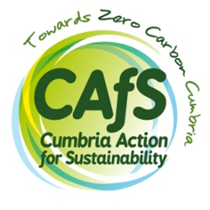
Expression of interest form: Digital Marketing and
Design Officer
Your name

Email

Phone number

What inspires you to express an interest in this role?
(400 words maximum)

How did you hear about the job?

Do you have the legal right to work in the UK? | Yes/No
Are you able to work on occasional evenings / weekends? | Yes/No
Are you able to travel around Cumbria for work purposes? | Yes/No
IT competency
Please list any Microsoft Office software and any other software or digital tools relevant to this role that you can use to a good working standard:

I declare that the information contained in this form is correct, to the best of my knowledge.

Date:

Signature:

Please send your completed form, CV and examples of your design work to: recruitment@cafs.org.uk
If you prefer to submit a paper copy, please send it to: CAfS, Eden Rural Foyer, Old London Road, Penrith, Cumbria CA11 8ET
Canvassing directly or indirectly will disqualify you from this recruitment. All information contained in this form will be treated as STRICTLY CONFIDENTIAL. For more information on how we collect, use and store your personal information, please see our privacy policy: https://cafs.org.uk/about-cafs/cafs-privacy-policy/.

