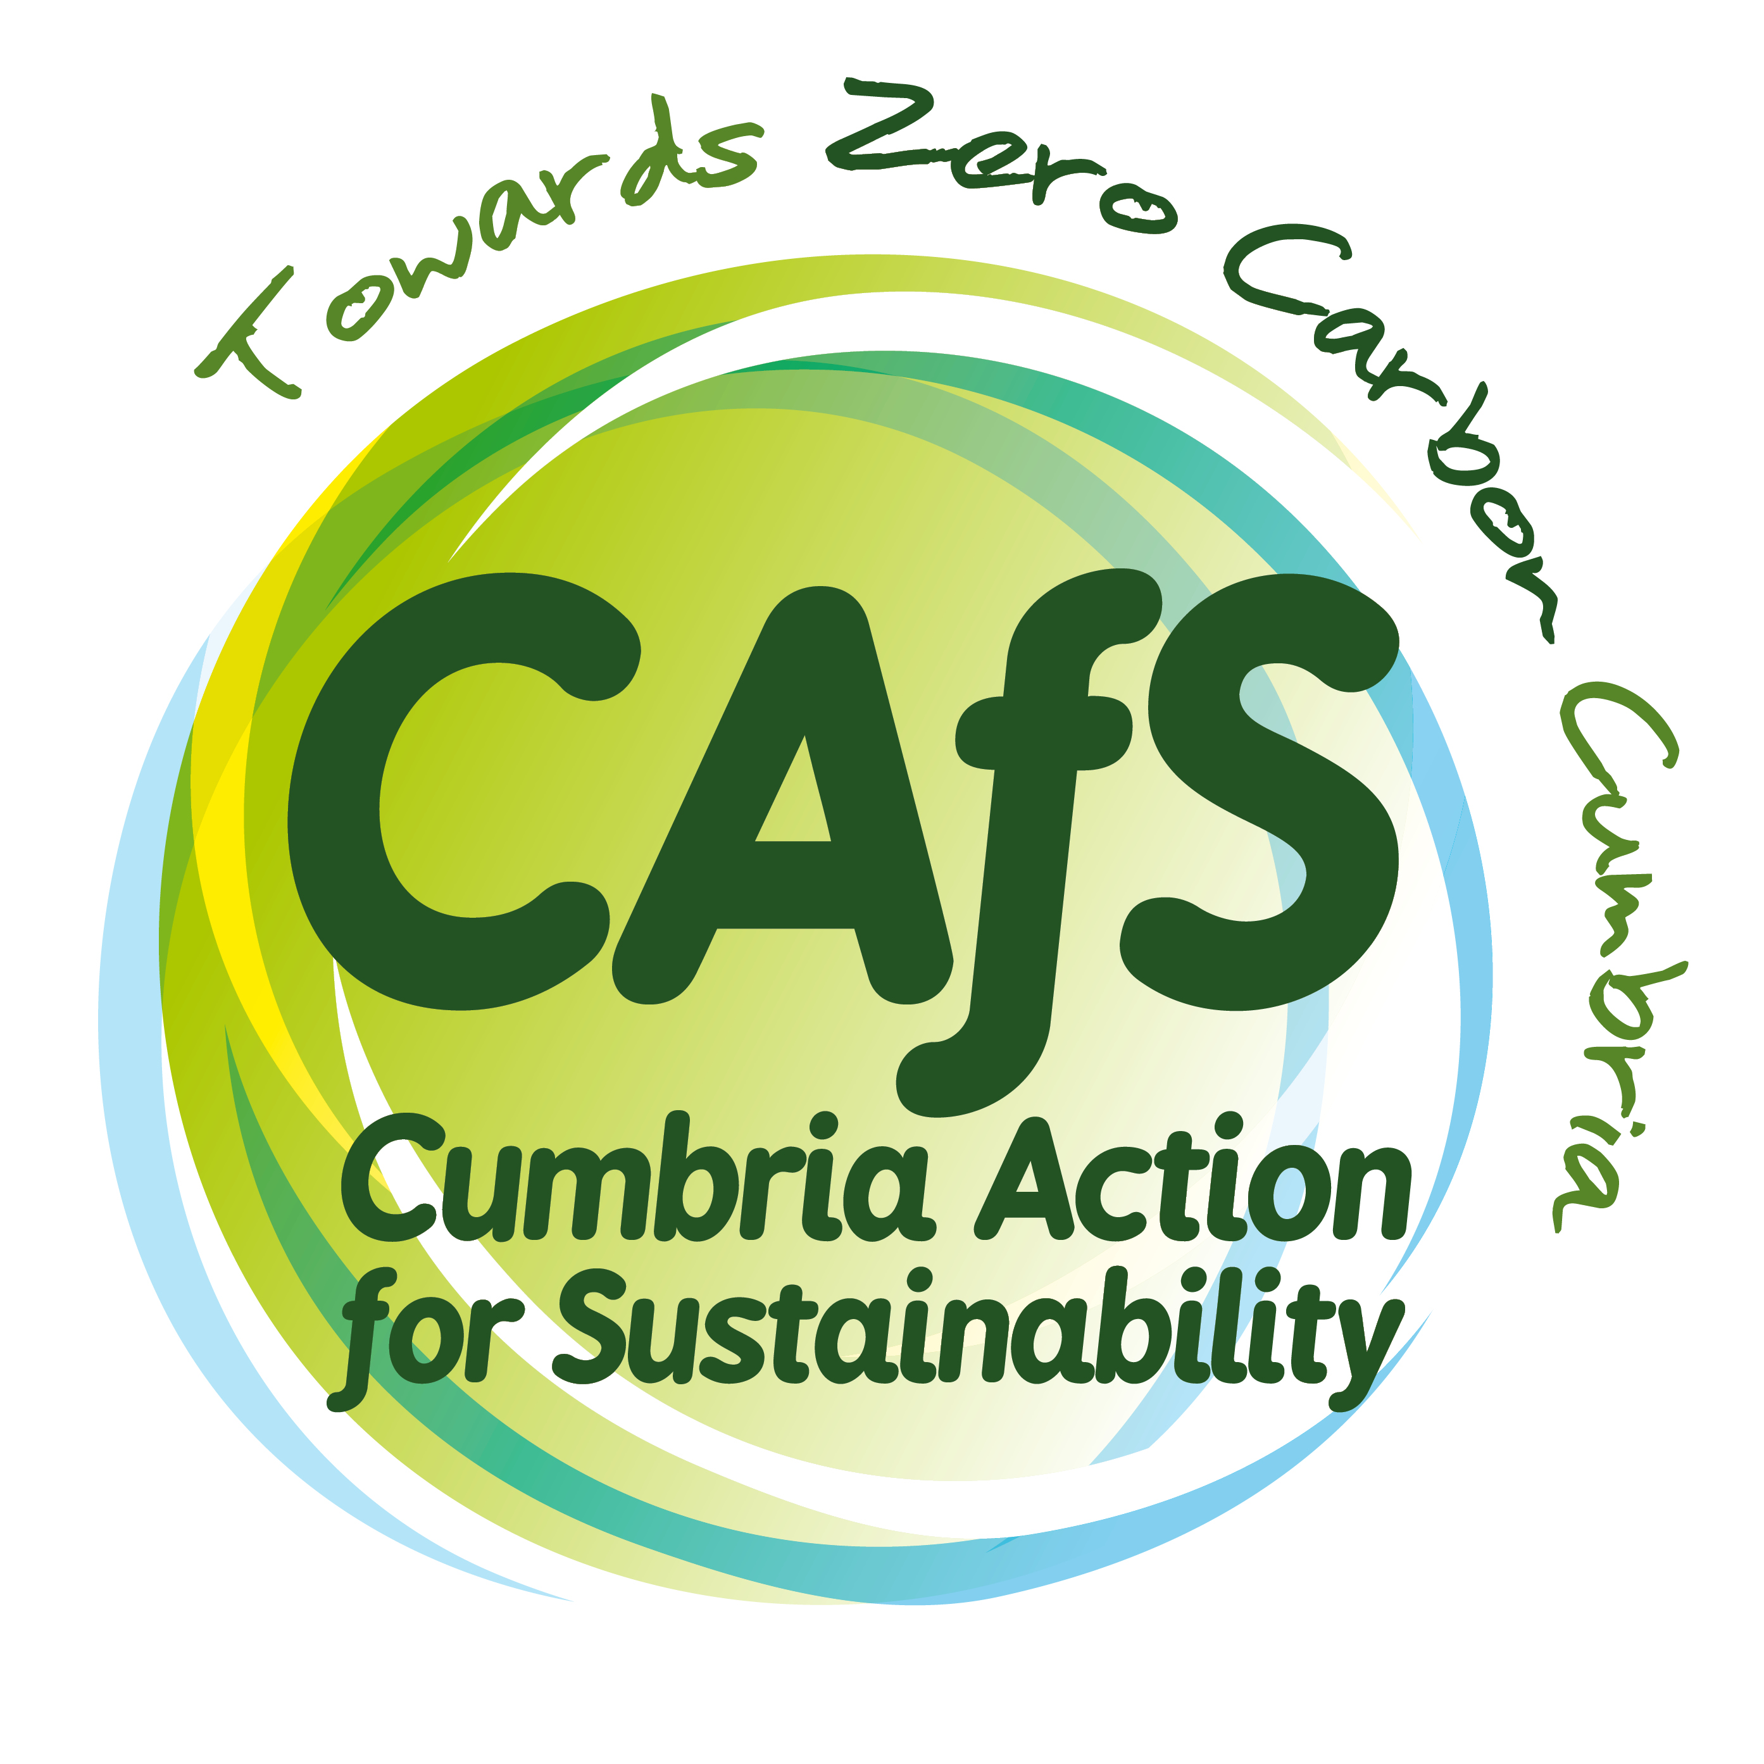
Digital Marketing and Design Officer

JOB DESCRIPTION

THE EMPLOYER: Cumbria Action for Sustainability (CAfS)

LOCATION: Contractually based at our office, Eden Rural Foyer, Old London Road, Penrith, CA11 8ET, however, homeworking can be agreed.

REPORTS TO: Marketing Manager

HOURS: 22.5-30 hours (3-4 days) a week. We are open to negotiation on the hours.

DURATION: Fixed-term contract for 12 months (with potential to extend subject to additional funding)

SALARY RANGE: £21,500 - £24,000 (full time equivalent) Starting salary is dependent on skills and experience.

RIGHT TO WORK: You must have an existing legal right to work in the UK.

START DATE: As soon as possible

APPLICATION BY: Please send your CV and portfolio / examples of design work, along with the Expression of Interest form by 9am | Wednesday 05 April to recruitment@cafs.org.uk

INTERVIEWS: Interviews will be held via Zoom on Wednesday 12 April
2023. Please let us know when submitting your application if you are unable
to make that date.

ABOUT CAfS
We are an award winning charity and the leading organisation providing advice, inspiration and support for action on climate change in Cumbria.

Our vision is a zero carbon Cumbria that is socially, environmentally and economically beneficial for all.

Our mission is to achieve net zero by 2037 or sooner by promoting and facilitating low carbon living and its benefits – inspiring and supporting individuals, communities, and organisations across Cumbria and beyond to decarbonise lives and businesses. We provide practical support for the development of low carbon plans and policies for individuals, communities, and organisations. We inspire behaviour change and seek to deliver sustained shifts from high to low carbon emissions through enabling new social norms and influencing key policies, strategies, and funding streams.

Our marketing and communications team plays a critical role in motivating and empowering individuals and organisations to take action on climate change. The team supports our many projects – from the high-profile Zero Carbon Cumbria programme, through to fundraising campaigns and our Cold to Cosy Homes Cumbria service. The team uses all forms of marketing and communications to broaden our reach, deepen our engagement and continue building our strong reputation and profile.

MAIN PURPOSE OF ROLE

- Responsible for the design output of the marketing team
- Managing our digital channels
- Delivering other aspects of our marketing plans

KEY TASKS

- Create and design digital assets such as social media graphics, email newsletters, and web pages that align with our brand guidelines and communicate our message effectively.
- Contribute to the development of marketing action plans by senior marketing staff, feeding in your insights and ideas.
- Create, schedule and monitor organic social media content.
- Digital advertising - developing ad content (text and imagery), set up and monitor campaigns on a range of platforms.
- Write and publish/distribute content such as newsletter articles, website pages and news posts, press releases, case studies, fact sheets.
- Take and source images and video footage, cataloguing media in CAfS’ digital libraries.
- Collate analytics and feed in ideas to support the evaluation and ongoing improvement of our communications.
- Contribute to audience research, such as setting up online surveys written by senior marketing staff
- Attend internal (and occasionally external) project meetings to support delivery of action plans.
- Keep up to date with developments in marketing and seek to apply new knowledge, tools and trends to improve communications outcomes
- Support colleagues across CAfS to adhere to relevant best practice and regulations
- Communicate and work collaboratively with the wider staff team and partner organisations.
- Carry out other tasks or projects needed from time to time, as directed by the manager or trustees.

PERSON SPECIFICATION

Essential skills and experience

- Experience of implementing digital ad campaigns using a range of social media channels and Google ads.
- Experience of editing websites.
- Understanding of search engine optimisation (SEO).
- Ability to source, optimise and edit images and video for a wide range of uses.
- Strong skills in graphic design, including experience with Canva and/or Adobe Creative Suite.
- Experience with email marketing platforms.
- Proactive and creative, with the ability to manage own workload, take responsibility for tasks, prioritising and scheduling work to meet deadlines, with minimal supervision.
- Ability to work cooperatively as part of a small team.
- High standard of written communication, grammar and spelling, with excellent proofreading abilities and a high level of attention to detail.
- Knowledge of GDPR and copyright.
- Good verbal communication skills.

Desirable skills and experience

- Experience of developing marketing plans.
- Experience of using social media management platforms, such as HootSuite and Buffer.
- Experience of evaluating the effectiveness of communications.
- Experience of adding content to websites and editing events using CRM (Customer Relationship Management).
- Understanding of and commitment to the aims and objectives of CAfS.

For more information about the role, please email Helena Davies, Marketing Manager: Helena.davies@cafs.org.uk

