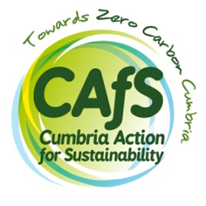
Marketing Officer

Please complete this covering form and submit it along with your CV.

First name: | Last name:

What has inspired you to apply for this job?
(Up to 400 words)

Do you have the legal right to work in the UK?  (Please note that CAfS is not licensed to sponsor employees) | Yes/No
Are you able to work on occasional evenings / weekends? | Yes/No
Are you able to travel around Cumbria for work purposes? | Yes/No
IT competency
Please list the Microsoft Office software and any other software or digital tools relevant to this role that you can use to a good working standard:

Referees
Please ensure that your CV includes two referees, with their name, occupation, postal address, email, phone number and relationship to you, or include this information here. At least one referee must be your present or most recent employer – please indicate which one. References will only be requested after interviews, once a conditional job offer has been made and accepted.

How did you hear about this job?

I declare that the information contained in this form and on my CV is correct, to the best of my knowledge.

Date:
Signature: (Electronic signature is fine)

Please send your completed form and CV to: recruitment@cafs.org.uk (putting the role title in the subject line)
If you prefer to submit a paper copy, please send it to: CAfS, Eden Rural Foyer, Old London Road, Penrith, Cumbria CA11 8ET
Canvassing directly or indirectly will disqualify you from this recruitment. All information contained in this form will be treated as STRICTLY CONFIDENTIAL. For more information on how we collect, use and store your personal information, please see our privacy policy: https://cafs.org.uk/about-cafs/cafs-privacy-policy/.
Only candidates invited to interview will be contacted.

