CELEBRATING GREAT BIG GREEN WEEK
Funding available for local events … take action now!
24th September – 2nd October 2022
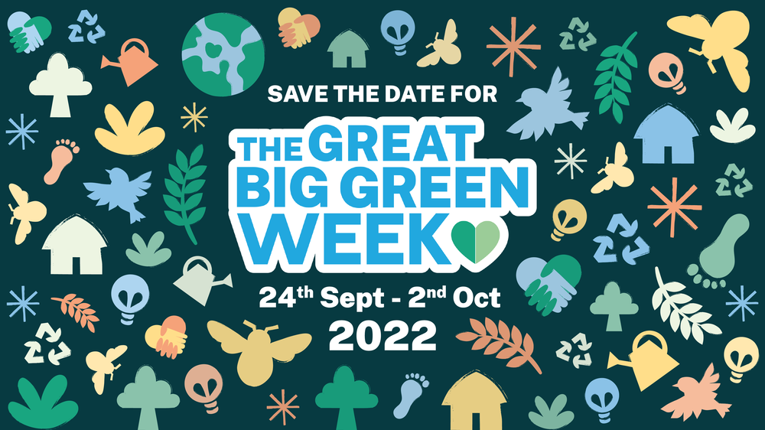
Proposal to deliver a community event / programme of events to celebrate Great Big Green Week (24th Sept – 2nd Oct).
*Please fill out the form below as soon as possible or by 12pm midday Friday 2nd September at the latest and send to helen.attewell@cafs.org.uk cc’d to communitygrants@cafs.org.uk
What is the name of your organisation?
Who is the key contact? (please include email and phone number)
Which area of Cumbria will your event be based in?
If you work with a particular group of people (eg. young people, BAME people, older people etc.), please tell us which groups.
When is your proposed event date/s?
Have you promoted your event on the GBGW website?

What would you like to do and why? (200 words max)

Please tell us:
How many people (beneficiaries) will take part in your event
How many volunteers will take part in your event

What will be the outcomes / benefits of your event? (200 words max)
E.g. how will it help raise awareness of climate change in your local area, how will the group benefit, how will it influence policy / behaviour change?

Please provide details of the costs in the table below. (Please also include quotes for any items of equipment or other capital expenditure)
Description | Costs
Total cost? | £
If you do not have your own bank account and would need CAfS to pay an invoice on your organisation’s behalf please contact Helen to discuss.

