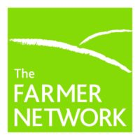
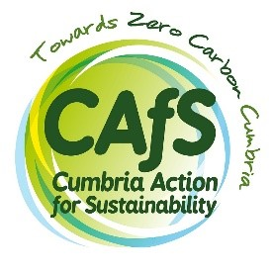

Farm Futures – farm renewables support
Expression of Interest
Please complete the following and email to Roe Baker at Cumbria Action for Sustainability:
roe.baker@cafs.org.uk
About you and your farm:
Name
Address
Email
Phone
Farm(s) name
Farm address
Are you the farm owner, tenant or both?
Farm size – hectares
Which district planning authority are you in?
Have you already calculated your farm carbon emissions?

Farm type – are you a dairy, beef, sheep, mixed stock, arable or poultry?
[Describe]

About your farm energy:
Describe how you think renewables will support your farm business. It’s useful to know here whether you’ve already done any research or if you are starting from scratch. Do you already have a particular kind of renewable generation in mind – solar PV, hydro, anaerobic digestion, micro renewables etc. Are you looking at barn roofs, ground mounted options or micro-options you can dismantle and move?
[Describe]

Are you on mains electricity supply? | Y /N
Are you interested in off grid solutions? | Y /N – describe
Do you already have sources of renewable energy installed? | Y / N – describe
When do you utilise most of your energy?  Please provide information on the pattern of use of the buildings (everyday/weekdays/daytime / night-time / milking / seasonal use) | Describe usage
Do you have a smart meter? | Y/N
Do you have 3 phase supply? | Y/N
Do you currently charge any electric vehicles? | Y/N - describe
Do you expect to have electric vehicles in the future? | Y/N - describe
5. Briefly describe or list how much you’ve already done to reduce your domestic or farm carbon footprint (examples of this this could be: a change in grazing pattern and cover cropping, hedge or tree planting, reduced use of fertiliser or insulation in your farmhouse roof – or you may already be on a carbon net zero contract with your milk distributor or supermarket)
[Describe]

6. If you’re a tenant please confirm whether you have the authority and support of the landowner to engage with us.
[Yes / no]

What happens next?
If successful we will be in contact with you as soon as possible to arrange next steps which will include our collecting the additional data and information mentioned and a farm visit by our consultant and project manager.

