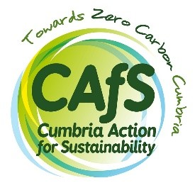

Switch on, power down
Barrow Businesses Beat Bills

Application form
Please complete and sign this form electronically and return it by email to molly.hogg@cafs.org.uk at your earliest convenience.
To provide evidence of support to the funder, at a later date we will provide you with a hard copy which will need to be over-signed in ink.

1. Business details
Business name
Business address
Company number
Website
Size | [micro/small/medium]
2. Applicant details
Name
Role
Email
Phone
3. Business type / sector
[Describe]
4. Business description (nature of business and description of size (e.g., number of sites or size of premises, number of staff, turnover etc) – approximately 100 words
[Describe]
5. Please confirm by checking the box that:
☐I have the authority from the business owner to participate in the program
☐I commit to engaging with CAfS within the timescales available
☐My business is not classed as farming, fishing or financial services (debt providers)
☐My business is not a franchise of a larger business, or part of a chain
☐My business has not already had a building energy audit
☐My business has not already benefitted from a Low Carbon Barrow Grant
☐My business will not exceed the De Minimis limit* by taking up this support offer.

* You are being offered assistance valued at £ 3,000 under the De Minimis Regulation 1407/2013 of 18.12.2014 OJ L351/1 of 24.12.2013. This allows a company to receive up to €200,000 (at the applicable European Commission monthly exchange rate) of De Minimis State aid over a rolling three-tax year period (including the current one). Businesses who will exceed this De Minimis limit by taking up this support offer may be excluded.
If you cannot positively confirm any of the above, pleased provide further details
[Describe]
6. Briefly describe why you would like our support – approximately 100 words
[Describe]
7. Please indicate your availability for working with us during the following periods:
Period | Good | OK | Not good
Sep 22 - Nov 22
Oct 22 – Dec 22
Nov 22 - Jan 23
Dec 22 - Feb 23

Signed ____________________________
Date ____________________________

