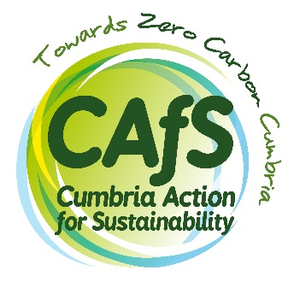

Expression of interest
Community Climate Champion (unpaid)

Through this project we hope to attract people with a mix of skills and experience so that community climate champions can learn from and support each other. We also hope to increase the skills, confidence and sense of agency of champions, through the experience they gain on the project.
Please do answer honestly about any training needs you may have, or any areas where you would like to build skills and confidence – this is exactly what we are aiming to do and will not count against you.
Please complete this form and return it to carbonliteracy@cafs.org.uk, by 9am on Wednesday 6th July 2022.
We will be in touch shortly afterwards.
Name:
Phone number:
Email address:
Town/Village:
Council district:
Where did you hear about this opportunity:

- Very briefly, why do you want to be a community climate champion? (100 words max)

- Which skills, experience, abilities and attitudes will you bring to the role of community climate champion (see role specification)? (200 words max)

- Which skills, experience, abilities, attitudes or other things would you hope to gain through being a community climate champion? (200 words max)

We want to improve the confidence of our champions through this project. The next two questions will help us to track this improvement for our funder and assess the success of the project.

- On a scale of 1 to 5 (where 1 is ‘not at all’ and 5 is ‘very’) how confident would you be delivering a session to a group now? (We are looking for a range of confidence levels)

- What would you like from us in order to improve your confidence? Equally, if you are very confident already, are you happy to support other volunteers in developing their confidence? (100 words max)

- Which organisations or networks do you want to deliver climate science and solutions sessions, events or talks to? (This might be training, talks, reading groups or facilitated conversations.) (200 words max)

