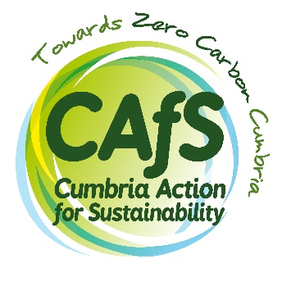
Expression of interest
Volunteer community climate trainer

Through this project we hope to attract people with a mix of skills and experience so that volunteer trainers can learn from and support each other. We also hope to increase the skills, confidence and sense of agency of volunteer trainers, through the experience they gain on the project.
Please do answer honestly about any training needs you may have, or any areas where you would like to build skills and confidence – this is exactly what we are aiming to do and will not count against you.
Please complete this form and return it to bernadette.calvey@cafs.org.uk, the community carbon literacy coordinator, by Monday 22 February 2021. We will be in touch shortly afterwards.

Name:
Phone number:
Email address:
Town:
Council district:

- Very briefly, why do you want to be a community climate trainer? (100 words max)

- Which skills, experience, abilities and attitudes will you bring to the role of volunteer community climate trainer? (200 words max)

- Which skills, experience, abilities, attitudes or other things would you hope to gain through being a volunteer community climate trainer? (200 words max)

We want to improve the confidence of our volunteers through this project. The next two questions will help us to track this improvement for our funder and assess the success of the project.

- On a scale of 1 to 5 (where 1 is ‘not at all’ and 5 is ‘very’) how confident would you be delivering a session to a group now?

- What would you like from us in order to improve your confidence? Equally, if you are very confident already, are you happy to support other volunteer trainers in developing their confidence? (100 words max)

- Which organisations or networks would you aim to deliver climate science and solutions sessions to? (This might be training, talks or facilitated conversations.) (200 words max)

