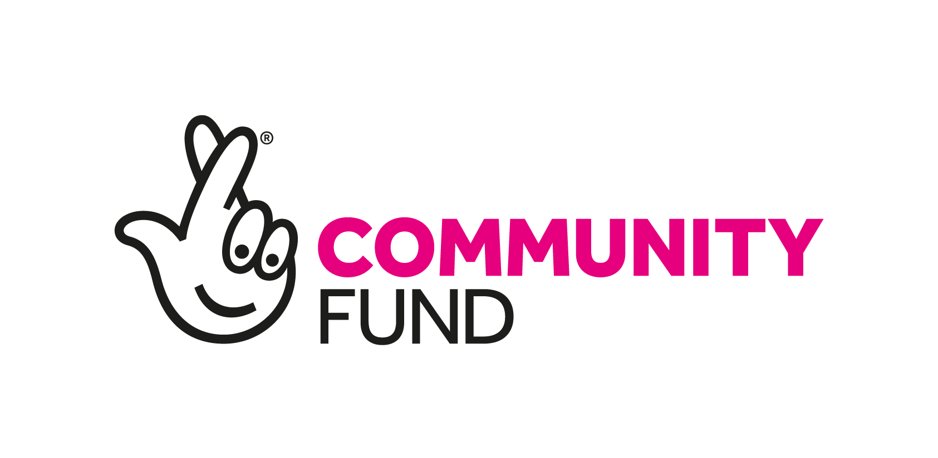

**PROJECT MANAGER – Zero Carbon Cumbria Project**

***Job Description***

**EMPLOYER:** Cumbria Action for Sustainability (CAfS).

**LOCATION:** Principally home working. Occasional meetings may be required at our office in Penrith (Rural Eden Foyer, Old London Road, Penrith, CA11 8ET) and other Cumbria locations when Covid-19 restrictions allow.

**REPORTS TO:** Chief Executive Officer.

**HOURS:** 22.5 hours a week (3 days). Flexible working hours.

**SALARY RANGE:** £24,000-£30,000 per annum full-time equivalent (£14,400 to £18,000 for the 22.5-hour week), depending on skills and experience.

**DURATION:** Fixed-term contract from 1 Nov 2020 (or sooner) to end Dec 2025.

**ABOUT CAFS:**

**Our vision** is a zero carbon Cumbria and we strive to bring about a better way of life, in balance with our environment.

**Our mission** is to empower and enable people, communities and businesses to live and work more sustainably by sharing our knowledge, practice, skills, networks and practical experience. We manage and deliver events, advice, training and practical projects across the county as well as providing specialist consultancy services to enable individuals, communities, businesses and local authorities to drive a shift towards a Zero Carbon Cumbria.

CAfS is an award-winning charity with a team of seventeen highly skilled staff, working with a pool of specialist contractors and volunteers to deliver around 20 major, transformational low-carbon projects each year. CAfS is the leading organisation in Cumbria showcasing low-carbon living, energy-efficiency improvements, renewable technology and reduced use of fossil fuels, both on a domestic scale and in the community. Now in our 22nd year, CAfS is the first point of reference in the county for information on sustainability. CAfS is a dynamic, pro-active and responsive organisation, continually striving to deliver effective projects that make an impact and drive real change towards a low-carbon future. As such, we continually initiate, scrutinise, refine and launch new projects, accessing funding from a variety of sources or earning income from delivering specialist services.

**BACKGROUND TO THE ZERO CARBON CUMBRIA PROJECT:**

Cumbria Action for Sustainability is one of a small number of organisations to be successfully awarded £2.5million from the National Lottery’s Climate Change Action Fund for the five year ‘Zero Carbon Cumbria Partnership – By the People, For the People’ project. The bid was led by CAfS on behalf of the Zero Carbon Cumbria Partnership (ZCCP) which involves nearly 70 organisations spanning the public, private and third sectors with the aim of cutting greenhouse gas emissions. Eleven of the organisations in the ZCCP will be involved in directly delivering elements of the Lottery-funded project and the whole partnership will be involved in wider decarbonisation programmes in order to reach the county’s zero carbon goal. There will be a Partnership Manager based at Cumbria County Council who will be co-ordinating the wider Partnership projects that fall outside of this National Lottery funded project.

Through this project, people who live, work and study in Cumbria will be able to take advantage of a whole range of opportunities to cut their own carbon footprint and that of their communities, playing their part in global actions to stop climate change.

The project will tackle some of the main sources of carbon emissions in Cumbria, with a particular focus on food, energy generation and the goods we buy. The sub projects have been devised by a range of community organisations and chosen because of their wide benefits to local communities. More information about the project is available here: <https://cafs.org.uk/our-projects/zero-carbon-cumbria-programme/>

**MAIN PURPOSE OF ROLE:**

The post has several key roles: principally to establish and coordinate the effective delivery of the Zero Carbon Cumbria project, to manage the day to day running of the project, manage the grant budget, coordinate and support delivery partners and liaise with the National Lottery, coordinate the project steering group, manage a team of project staff and work closely with the delivery partners.

**KEY AREAS OF RESPONSIBILITY:**

* Take overall responsibility for the coordination and management of the Zero Carbon Cumbria: By the People, For the People lottery-funded project.
* Recruit and manage the Communications Manager, Events & Training Officer, Community Carbon Literacy Officer and Cumbria Sustainability Network Coordinator and manage the Project Administrator.
* Work closely with the Partnership Manager to ensure the smooth running of the project.
* Develop a rolling programme plan which enables activities, outcomes and budgets to be effectively monitored.
* Develop an effective programme management framework which will allow the whole suite of projects to be viewed as an integrated whole, and within which partners can develop detailed and consistent project plans (while being mindful of the need for effort to be proportional to the scale of each partner’s project).
* Develop a framework to monitor, measure, evaluate and report on success and produce routine and exception reports on the programme (budget, capacity, deliverables, outcomes etc) which allow the CAfS CEO, Trustees, The Lottery and all delivery partners to understand and respond to the progress of the project.
* Work alongside Project Delivery Partners to maximise outcomes and ensure partners are delivering to plan, capturing learning, sharing information and networking locally and nationally.
* The effective management and mitigation of project risks.

**TASKS TO INCLUDE**

* To co-chair meetings of the Zero Carbon Cumbria Partnership.
* To convene the Project Board on a quarterly basis, ensuring adequate representation from delivery partners and key communities, and reporting mechanisms.
* To coordinate all payment and reporting processes for the project.
* To work alongside partners and project staff to raise additional funds that will allow the benefits of the programme to be maximised.
* To develop consultant briefs, commission, contract and manage consultants to carry out a range of expert advice and project work.
* To manage the central funding pots for the partnership: to overcome disadvantage; share learning; and access expert advice where needed.
* To liaise with other National Lottery Climate Action Fund grant recipients.
* To work with all delivery partners to ensure consistency and timeliness regarding staff recruitment and/or contracting delivery of posts in their organisations.
* To act as media spokesperson for the project as required.
* To maintain and ensure compliance with the project delivery partnership agreement.
* To adhere to CAfS project management processes.
* To develop and maintain all project documentation including project GANTT chart, risk log, action log etc.
* To assess and manage any changes to the project baseline.
* To arrange and deliver project planning meetings.

***Person Specification***

**Essential skills and attributes**:

* An understanding of and personal commitment to the objectives that CAfS seeks to deliver.
* Ability to develop a shared vision across a diverse and multi-organisational project and drive momentum to deliver agreed goals.
* Strong networking skills and ability to effectively communicate and negotiate with a wide range of partners from a variety of backgrounds, including community groups and young people.
* Experience of complex programme management, including planning, organising, scheduling, budget management, financial analysis, risk management, management information, report writing and monitoring and evaluation of multiple projects.
* Experience of capturing and sharing learning.
* Experience of tendering, letting, and managing contracts and partnership agreements.
* Experience of recruiting and managing staff.
* Ability and willingness to prioritise, work to deadlines and juggle multiple priorities.
* Ability to travel independently throughout rural Cumbria.
* Understanding of relevant requirements of Data Protection Act 2018.
* Ability to work to tight deadlines.
* Flexible working including evening and weekend working by agreement.
* Computer skills specifically Microsoft office applications, including Excel, and PowerPoint, Zoom and MS Teams.

**Desirable criteria**

The following attributes are **desirable** but not essential:

* A degree-level qualification in a relevant field e.g. project management, sustainability, community development.
* Experience of delivering community-led projects or schemes, especially concerning energy generation, food growing and sourcing, and repair cafes or managing other emission reduction programmes.
* Experience of reporting to project boards/steering groups and major funders.
* Experience in running online meetings and webinars.
* Experience of liaising and reporting to The National Lottery.

If you would like more information about the role, please email Karen Mitchell, CEO: karen@cafs.org.uk